Conwy Safeguarding Community of Practice – update 16 April 2020
A community of practice is a group of people who share a concern or a passion for something they do, and learn how to do it better as they interact regularly” Wenger-Trayner
Hello there,
On 23 April we were due to hold a Safeguarding Community of Practice event. Obviously, this has had to be cancelled and is yet another casualty of the Covid 19 pandemic currently blighting our lives.
However, not to be beaten we have put some information together for you plus a few links below. We hope you will find it useful during these extraordinary times and help safeguard yourselves and the communities you support.
North Wales Safeguarding Board
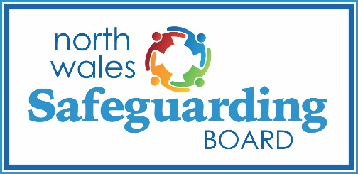
NWSB now has a dedicated Covid 19 web page and plans to update it on a weekly basis to ensure that any local / national practice guides will be available for all officers across the region to access to support their practice in North Wales. https://www.northwalessafeguardingboard.wales/covid19/ Also, don’t forget to keep an eye on the 7 minute briefings that can be found by clicking on the ‘Resources’ tab. New topics being added all the time and are a useful source of information.
Disclosure & Barring Service and Coronovirus (Covid 19)
A collection of factsheets, updated guidelines and news stories related to DBS and coronavirus https://www.gov.uk/guidance/covid-19-how-dbs-is-supporting-the-fight-against-coronavirus.
Advice and FAQs for organising a community volunteer group, information for individuals wanting to assist those in their local community.https://www.gov.uk/government/publications/safeguarding-factsheet-community-volunteers-during-covid-19-outbreak/safeguarding-and-dbs-factsheet-faqs
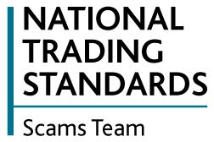
National Trading Standards – Scams Team
Sadly there is a lot of evidence that unscrupulous criminals are taking advantage of the Covid 19 pandemic exploiting members of the public particularly vulnerable people. People are being encouraged to protect their neighbours by joining Friends Against Scams, which provides
free online training to empower people to take a stand against scams. To complete the online modules, visit www.friendsagainstscams.org.uk.

Volunteering in Social Care Settings during the Covid 19 cisis
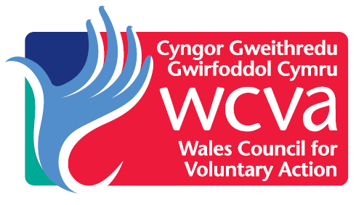
Social Care Wales and WCVA have developed guidance for volunteering in social care settings. The guidance provides information on the general principles of volunteering for staff who are or likely to manage volunteers within social care, whether they be from a local authority, an independent provider or a voluntary sector organisation contracted to provide care and support services
The information includes a useful cone page checklist summarising the guidance and things that need to be considered. https://socialcare.wales/service-improvement/guidance-for-volunteering-in-social-care-settings#section-35840-anchor
Violence Against Women Domestic Abuse and Sexual Violence
Social distancing and Government restrictions on movement means that for some they could be trapped in their homes with an abuser. In addition to increased funding to support various initiatives aimed at supporting those fleeing domestic abuse and other forms of violence, the Welsh Government has opened up the online VAWDASV e-learning module for all. This is to enable people spot the signs of VAWDASV and know how to get help. Access to the module is via this link https://learning2.wales.nhs.uk/course/view.php?id=71 and select the ‘log on as guest’ option.
Food safety for community cooking and food banks
Hygiene and allergy advice for individuals and groups preparing meals to share in their community https://www.food.gov.uk/safety-hygiene/food-safety-for-community-cooking-and-food-banks
Anyone wanting to access Food Hygiene or Infection Control online learning can email sc.training@conwy.gov.uk with Name, Email Address and advise that they are contacting Via CVSV and the organisation they are volunteering for and the Workforce Development Team can arrange access for them.
Conwy County Borough Council Safeguarding Training
In order to assist with the prevention and containment of the Covid 19 virus, all face to face training by the the Workforce Development & Learning Team has been cancelled until further notice. However the team has provided their training slides for your use, which include information about the Wales Safeguarding procedures. Double click on the icon to access the slides.

That’s all for now folks, keep safe and we look forward to seeing you soon.

