Community Services Transformation Programme
Easy Read

The Health Board and the Council in Conwy and Denbighshire are working with other organisations who help people.

All the organisations want to work together better.

They want to improve the help and support they give.

Conwy and Denbighshire Health and Social Care Citizens’ Assembly

There will be a new group talking about health care and social care.

The new group will be called a Citizens’ Assembly.

The group will listen to what people say.

The new group will help make health care and social care better.

It will help people who work for health care and social care to work together more.

Citizens’ Assembly
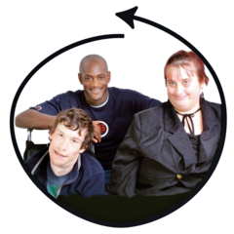 | You are invited to join the new group.
Citizens’ Assembly | The new group will be called a Citizens’ Assembly.
 | The group will meet 4 times.
The meetings will be on-line.

Each meeting will last for 2 hours.
 | Other people who are interested in health care and social care will be there.
How will this work in Conwy and Denbighshire?
 | You can talk about health care and social care.
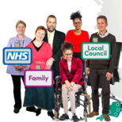 | You can talk about working together
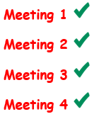 | There are 4 meetings.  We would like you to come to every meeting.
 | The meetings are in June, July and August.
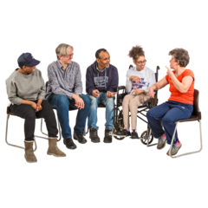 | We want to hear from you.
 | There is help to join the group if you need it.
How do I take part?
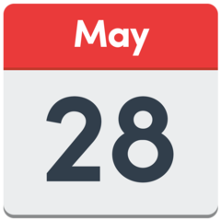 | If you want to come to the meetings tell us before 28 May 2021.
Fill in this form to tell us you want to join.

Link to form

You can ask questions about the group.

Talk to Jacqueline Bickers.

Jacqueline.bickers@conwy.gov.uk

