
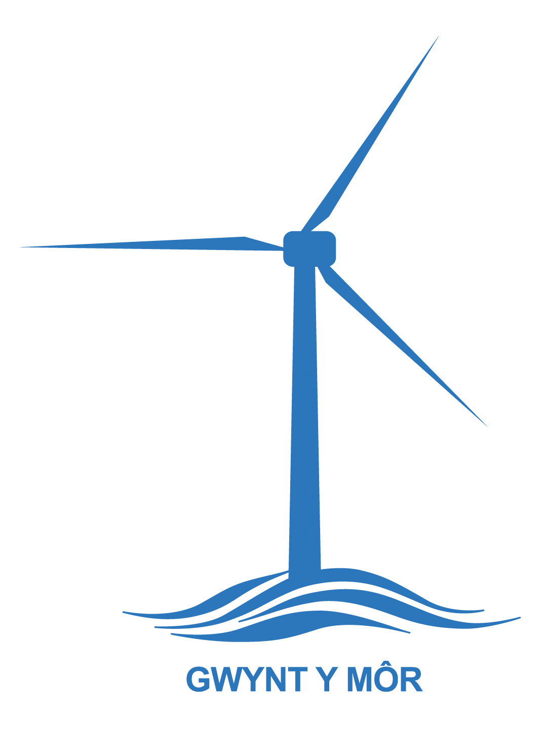
GYM/MG/02

Gwynt y Môr Community Fund
Covid 19 Response Grant
Applicant Guidelines

These notes should be read before applications are submitted to the Gwynt y Môr Community Fund Micro Grant Programme.

We highly recommend contacting CVSC Funding team before submitting an application
Neil Pringle: 01492 523845, email: neilpringle@cvsc.org.uk
Sabina Dunkling: 01492 523843, email:sabinadunkling@cvsc.org.uk
Aled Roberts: 01492 523856, email:aledroberts@cvsc.org.uk

For further help or advice please contact:

For Conwy and Denbighshire : Neil Pringle /Sabina Dunkling/ Aled Roberts (as above)

For Flintshire : Heather Hicks FLVC, Corlan Unit 3, Mold Business Park, Wrexham Road Mold, CH71XP
01352 744000 Email : heather.hicks@flvc.org.uk

What is the Gwynt y Môr Community Corvid 19 response Grant Fund?
Gwynt y Môr is one of the the world’s largest operating offshore wind farm, located off the North Wales coast. It is a £2bn partnership between RWE Innogy, Stadtwerke München GmbH and Siemens. The Gwynt y Môr Community Fund is money provided by the partnership to support coastal communities in Conwy, Denbighshire and Flintshire.

Launched in July 2015 the scheme is independently managed by CVSC, in association with DVSC and FLVC. The Covid 19 response Grants panel will consist of officers from the respective CVC (Community Voluntary Council) area.

COVID 19 response Grant Fund : Overview

The Covid 19 response Grants Fund will provide funding opportunities from

.£100 to £5,000.00

All applicants will be required to complete and submit a simple application form. Your application will need to support one of the fund’s three themes:

Theme 1: Building strong, cohesive and sustainable communities

- Supporting volunteers to deliver response services
- Tackling Social isolation caused by self isolation
- Getting supplies needed to people
- Building community resilience

Theme 2: Developing prosperous, enterprising communities with
strong economic growth

- Helping people/organisations to diversify / develop new or improve existing skills
- Purchase of technology to support changing service delivery
Supporting community action/groups to remain economically stable

Theme 3: Reducing poverty and inequality in communities
- Increasing access to supplies and services to those who need them the most
- Improving the health/welfare outcomes for marginalised groups
- Ensuring information is accessible to all

Eligible Organisations
Organisations within the specified area of benefit* will require a written constitution, a set of rules, or a governing document and will need to have a bank or building society account (in the name of the organisation) with a minimum of two signatories in place before applying for a grant.
Eligible Organisations, who can apply for funding include:

Voluntary community groups; Parish / Community Councils / Town Councils; Social enterprises; co-operatives, social firms, community owned enterprises and community interest companies and provided they operate on a not-for-profit basis *See map on page 6


Exclusions
Grants will not be available for:
- Commercial organisations
- Individuals
- Any works considered a statutory responsibility, such as scheduled transport services, works to public highways and public car parks
- Projects that are religious in focus or that support a party political campaign or cause or may bring the fund or the funder into disrepute
- Retrospective funding, i.e. projects that have already been completed, whether or not already paid for
- Building up a reserve or surplus, whether distributable or not
- Organisations that do not have two signatories per financial transaction (must not be related) cannot apply


Completing the Application Form

Section 1: About you/your organisation

- Tell us who you are and where / how do we contact you ?
- What is your organisation type? (e.g. Voluntary club/association, youth club/organisation, charity, town/community council, environmental group etc.)
- What does your organisation do (e.g. a group of local volunteers organising deliveries for vulnerable local people)


Section 2: About your project

- Tell us about your project……...
- What do you want to do? Why do you want to do it?
- What difference will it make in your community in response to this pandemic?
- How many people do you think the project will benefit?
- How many volunteers are / will be involved?
- When do you want to start, and tell us when the project will finish?
- You may write in paragraph form, bullet points or continue on a separate sheet of paper – but try to be concise, don’t write an essay! .
- Only by clearly stating what you want to do, will the assessing panel understand what you are trying to do!
- Remember, you must highlight the benefits of the proposed scheme
- Be realistic in what you are trying to achieve!


Section 3: Financial Details

- This section deals with project costs
- You should list every item you are seeking funding for
- Include the net cost, the VAT element and total cost
- Finally, at the bottom of this section state how much grant aid you are seeking


Section 4: Monitoring

- Monitoring will be proportionate to level of funding
- Gwynt Y Môr will require receipts of capital expenditure over £500
- Short update/report via email on progress will be required

PLEASE ENSURE THAT YOU SPEAK TO A CVSC OFFICER BEFORE SUBMITTING YOUR APPLICATION.

DATA PROTECTION AND AUTHORISATION OF USE

Community and Voluntary Support Conwy (CVSC) operating on behalf of the Gwynt y Môr Community Benefit Fund, will use will use the information contained in your application document, including personal information, to process your funding application. This involves sharing with our partners DVSC, FLVC, Denbighshire and Conwy Councils. The information will be entered on a database utilised by CVSC and its Third Sector Support Wales partners (further information and our privacy notice are available from thirdsectorsupport.wales). The information will be held for the length of the GYM project and then destroyed securely

Please return completed Application Forms to:

Grants team (Conwy & Denbs) Heather Hicks (Flintshire)
CVSC FLVC
7 Rhiw Road Corlan, Unit 3
Colwyn Bay Mold Business Park
Conwy Wrexham Road
LL29 7TG Mold
Flintshire
CH71 1XP
Email : grants@cvsc.org.uk heather.hicks@flvc.org.uk



