Clocaenog Forest Wind Farm Fund
Covid-19 Application Form

Make sure you have read the Guidelines for Applicants before you complete this application.
Please write / type clearly in black or blue ink.
Please answer every question. Where the question is not appropriate to your organisation or project please write Not Applicable (N/A)

Section 1: About Your Organisation

Name of organisation

Address of your organisation | Post Code:
Project lead name
Project lead contact details | Email:  Phone:
Organisation type (Please describe your organisation’s work and structure)

Section 2: About your project

Please describe your project, why it is needed and what are the community benefits /outcomes. (What are you going to do? How many people will benefit? Does it provide volunteering opportunities?)

What are the planned project start /finish dates? | / / to / /

Section 3: Project Costs

Expenditure | Cost  £ | VAT  £ | Total  £
Total Project Costs =

Other Grants / Funds applied for or received
(Please list) =
Clocaenog emergency grant requested =

Is your Organisation registered for V.A.T.? | Yes No  If yes; you will be expected to reclaim V.A.T. on your project and any grant paid will exclude the V.A.T. element

Section 4: Project Check List

Please ensure the following documents have been included as part of your application

- Copy of organisation constitution

- Bank Statement

- Evidence of community support for project if available

Bank Details
Account Name:

Bank name & Address:

Sort Code: Account No.

I/we confirm that our internal financial procedures require a minimum of two signatories (must not be related) per financial transaction.

Names of authorised signatories: 1.…………………………………………………………..

2 ………………………………………………………..…
.

To be completed by a representative of the organisation/group:

I confirm that all the information on this form is true and correct.

Representative’s name: | Position:
Phone No.: | E-mail:
Signature: | Date:

DATA PROTECTION AND AUTHORISATION OF USE
Community and Voluntary Support Conwy (CVSC) operating on behalf of Clocaenog, will use your personal information in order to process your funding application, and will be entered on a database utilised by CVSC and relevant information will be shared with our key partners for this fund, namely Denbighshire Voluntary Services Council, Denbighshire County Council and Cadwyn Clwyd. The information will be held for the length of Clocaenog project and then destroyed securely.

Please return completed Application Form and supporting documents to:

grants@cvsc.org.uk

For further help or advice at CVSC please contact:
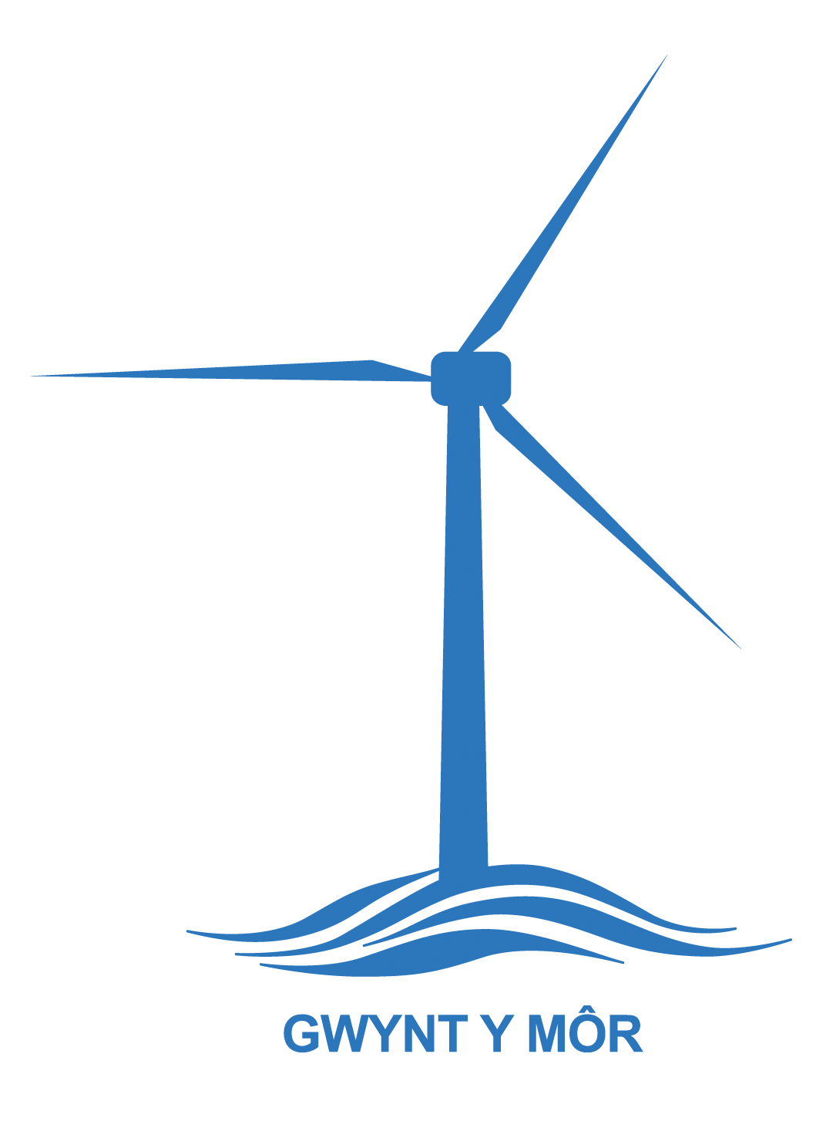
CVSC Neil Pringle: 01492 523845,
email: neilpringle@cvsc.org.uk

CVSC Aled Roberts: 01492 523856,
email: aledroberts@cvsc.org.uk

CVSC Esyllt Adair: 01492 523855,
Email: esylltadair@cvsc.org.uk

Further guidance and information is also available from the following.

Denbighshire County Council:
communitydevelopment@denbighshire.gov.uk

For Cadwyn Clwyd:
Lowri Owain, 07969 966820, email lowri.owain@cadwynclwyd.co.uk

